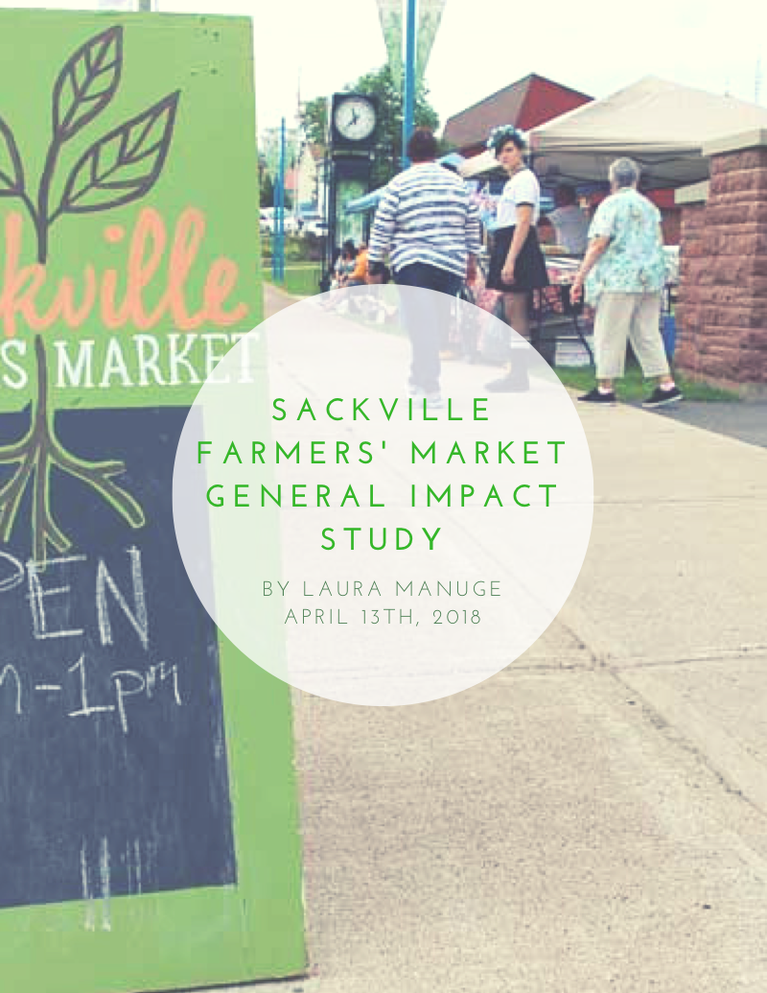

Contents

- Foreword

- Introduction
Project description

- Background Information
Farmers’ Markets in Canada
Local Food Systems and Economies
Food Security and Farmers’ Markets

- Research Methodology

- Survey Results
Consumer Survey
Vendor Survey

- Recommendations and Conclusions
Case Studies
- CalFresh Program in California, USA
- Wolfville Farmers’ Market
Suggestions
Conclusions

Foreword

Countless people have had the experience of waking up early on the weekend to attend their local farmers’ market. Or, perhaps they are travelling to a faraway farmers’ market to experience a different locale. While every farmers’ market is unique and operates in its own distinctive way, their general appeal can be appreciated no matter which one you attend or how often you go. Farmers’ markets provide an exceptionally unique shopping experience that can be appreciated whether or not you identify as a localvore, as each item purchased has an amount of care put into its creation that is not typically found at big box stores. Typically, products purchased at farmers’ markets also facilitate environmentally conscious and nutritious decision making amongst consumers. In addition to this, Farmers’ Markets provide a certain level or personal interaction that consumers find important and attractive. This project has allowed me to appreciate farmers’ markets as hubs of community interactions, as well as the very special environment that they offer. Recently having spent a significant amount of energy thinking about community spaces, I believe that there is a biological need and craving for the type of interaction and lifestyle that farmers’ markets give people the opportunity to experience. After completing this study, I believe that the Sackville Farmer’s Market provides this need to the town of Sackville, and has the ability to be a platform that can even further support community well-being.

Introduction

The purpose of this project is to develop a new economic impact study with the aim of providing useful, quantitative and qualitative data through examining the effects of the Sackville Farmers' Market on Sackville's economy. This project evolved in a way that its results provided more of a generalized impact study of the market within Sackville, focusing on the economic and social values of both consumers and vendors who attended the Sackville Farmers’ Market.
This report will outline some important background information about farmers’ markets on both a regional, national, and international scale, and will also discuss some key literature relating to market operations. It will then discuss the development of this project including the methodology used and the results that were found. Prior to conducing, this report will outline some of my person recommendations for the market including potential channels for collaboration and opportunities for the Sackville Farmers’ Market to better connect with current and potential consumers and vendors.
The last impact study for this market was completed in 2014 during the summer months (May and June). This project aims to specifically provide a snapshot of the Sackville Farmers’ Market impact on the community during the winter, in March. Additionally, the survey distributed in 2014 was distributed on two Saturdays and received

Background Information

Farmers’ Markets in Canada

According to the National Farmer’s Market Impact Study conducted in 2009 by Experience Renewal Solutions Inc., which studied over 508 farmers’ markets of various sizes, the average consumer spending amount is $32. Below are some additional collected data points from this study:
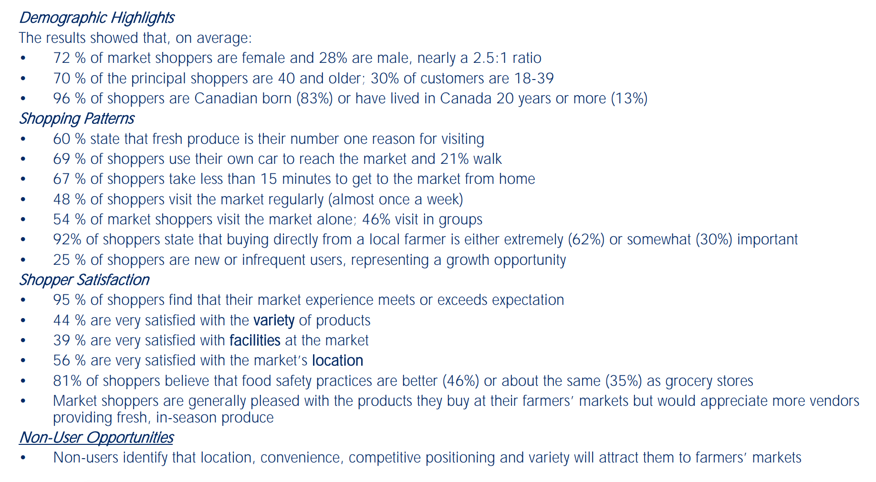

Local Food Systems and Economies

James D. Rossi, Thomas G. Johnson and Mary Hendrickson write about the impacts that local food systems can have on rural and small-town economies in their 2017 study entitled “The Economic Impacts of Local and Conventional Food Sales”, saying that local food systems can be easily distinguished by looking at direct-to-consumer food sales, most of which happen at regional farmers’ markets.
Local food systems can help with the economic development of a small town by circulating money within the local economy for a longer period of time, increasing spending at other local shops, and reinforcing local business networks (Bullock, 2000). Friends of the Earth note in their article “The Economic Benefits of Farmers’ Markets” that 85% of farmers markets in the United States are economically self-sustaining and have a higher multiplier effect in the towns that they exist within. They also say that: “In contrast, spending at supermarkets for example greatly reduces the local multiplier, as most revenue leaves the local area immediately” (Bullock, 6).
For many consumers, farmers’ market are also where they go to find natural or certified organic foods. According to the Government of New Brunswick, organic food is certified in accordance with the Organic Products Regulations and the Canadian Organic Standards, which act as a regulatory framework for all food claiming to be organic. There is a cost associated with this certification, as well as a certification process, according to the Government of New Brunswick.
Famers’ Markets have also increased in popularity with the strengthening of the local food, or “localvore” movement, through which conscious consumers try to buy as much food locally as possible. In some cases, such as in “The 100-Mile Diet” by J.B. Mackinnon, consumers have restricted themselves to only eating locally grown food as a way of fueling the local economy and eating more healthy, nutritious food.

Food Security and Farmers’ Markets
According to Stats Canada, 1 in 8 households are food insecure

PROOF, which is an research team based out of the University of Toronto studying food insecurity in Canada, defines a food insecure household as:

“inadequate or insecure access to food due to financial constraints. It is a serious problem in Canada that negatively impacts physical, mental, and social health, and costs our healthcare system considerably” (2018).

In their 1998 action plan for food security, the Canadian government acknowledges that “regional climactic phenomenon” and “civil strife” also play a role in food insecurity. In 2012, PROOF notes that New Brunswick’s population was 15.6% food insecure, which was approximately 47,000 households. This is 3.2% above the national average at the time, which was 12.4%.
To provide a snapshot of global food insecurity, we can look to the fact that after a full decade of world hunger declining, the number of undernourished people on the planet increased from 777 million in 2015 to 875 million in 2016 according to the United Nations Food and Agriculture Organization. Now, that number is closer to 815 million with an expected 2 billion to join by 2050.
Narrowing our scope to a more local scale, a grassroots organization dedicated to supporting the next generation of young farmers known as The Greenhorns indicated that farmers’ markets have the potential to play a significant role in addressing food insecurity in the communities in which they are located, saying:

“Small family farms have been shown to be the most effective, per acre, at ecological stewardship, biodiversity and production of nutrition. [They] employ more workers, supporting the local economy and rural prosperity … and can adapt and change with the market demands or shifts in climate” (2016)

It is also important to note that nutrition plays a large role in nourishing a community and preventing food insecurity, as poor nutrition causes people to become ill and miss out on many opportunities. Farmers Markets help to develop a community food system, as they often have a close connection to the particular needs of a community.
Farmers markets can also help to improve the diets of food insecure households in a community by providing access to nutritious, natural and organic food options.

Research Methodology

This aim of collecting data for the purpose of this project was to figure out the general demographics, habits, and wants of both the consumers and vendors of the Sackville Farmers’ Market. This was completed by administering a paper-based survey, over the course of five weeks (consumer survey) and two weeks (vendor survey).
The questions on both surveys were adapted from some questions within the Farmers Market Impact Toolkit and Users Guide published by the British Columbia association of Farmers Markets, which is used to demonstrate the value of farmers’ markets within their communities. This toolkit has been widely utilized by farmers’ markets of various scales across Canada, indicating that it is not only a standardized method but also a reliable one. However, in order to provide a wider scope of community perspectives on the market, the survey was administered over 5 market days rather than the recommended 3, and approximately 100 consumer surveys were administered rather than the suggested 40-50.

Results
This portion of the report will focus on displaying and providing a breakdown of the results collected from the consumer and vendor surveys. The surveys, as distributed, are attached as appendix (a) and appendix (b). Additionally, attached as appendix (c) is a “snapshot” of the overall results that can be used to briefly summarize what will be discussed below.

Consumer Survey
In total the consumer survey received 94 respondents. Because it was indicated to respondents that each question was optional, not every question received 94 answers. The average amount of answers for each question was 88.

Market Demographics
The following set of results gives a glimpse of the population that is shopping at the market as a demographic profile:
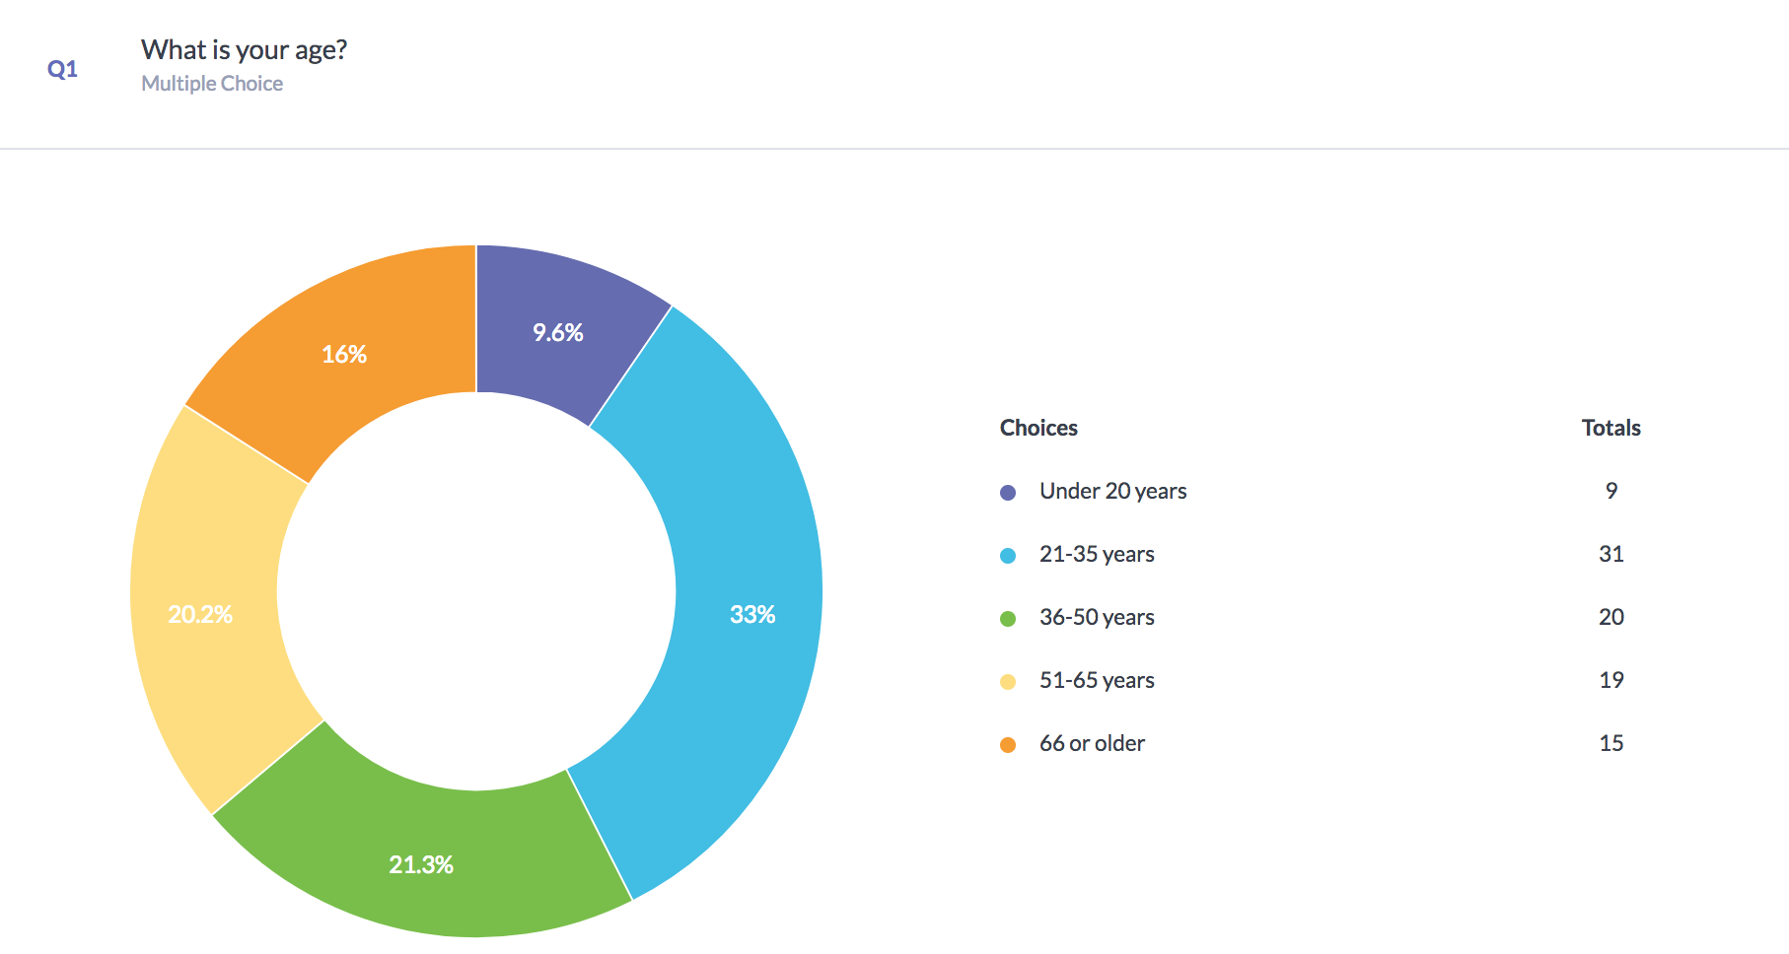

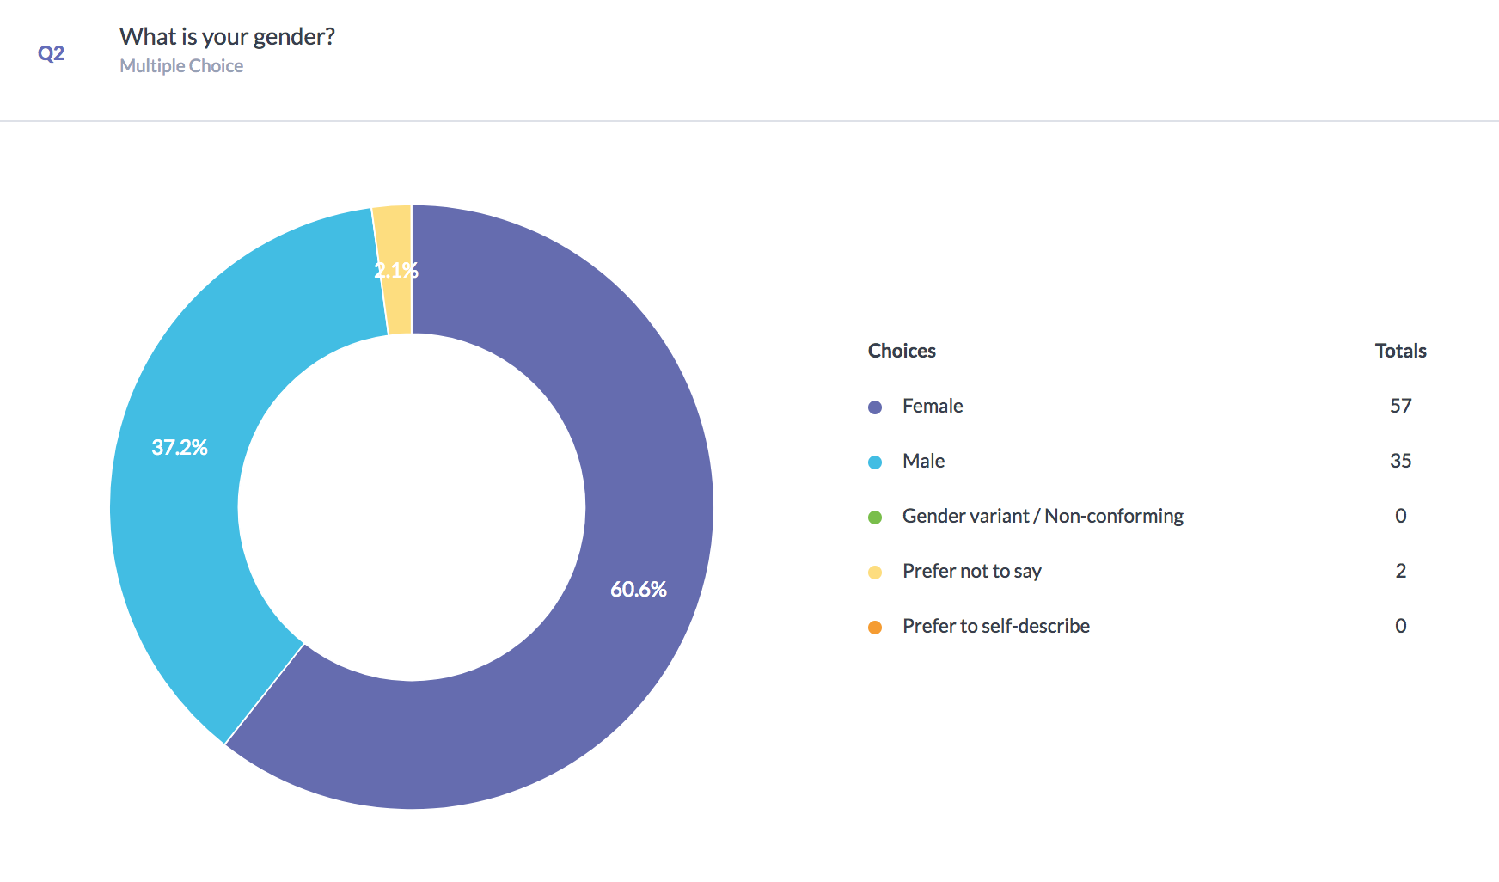

As shown in the graphics above, there is a wide age range for consumers, but most (54.3%) are between the ages of 21 – 50. Additionally, the majority of market customers are female (60.6%).

University Affiliations
The following two questions were not adapted from the Farmers Market Impact Toolkit and Users Guide, but were included specifically to see what number of consumers have a relation to the university:

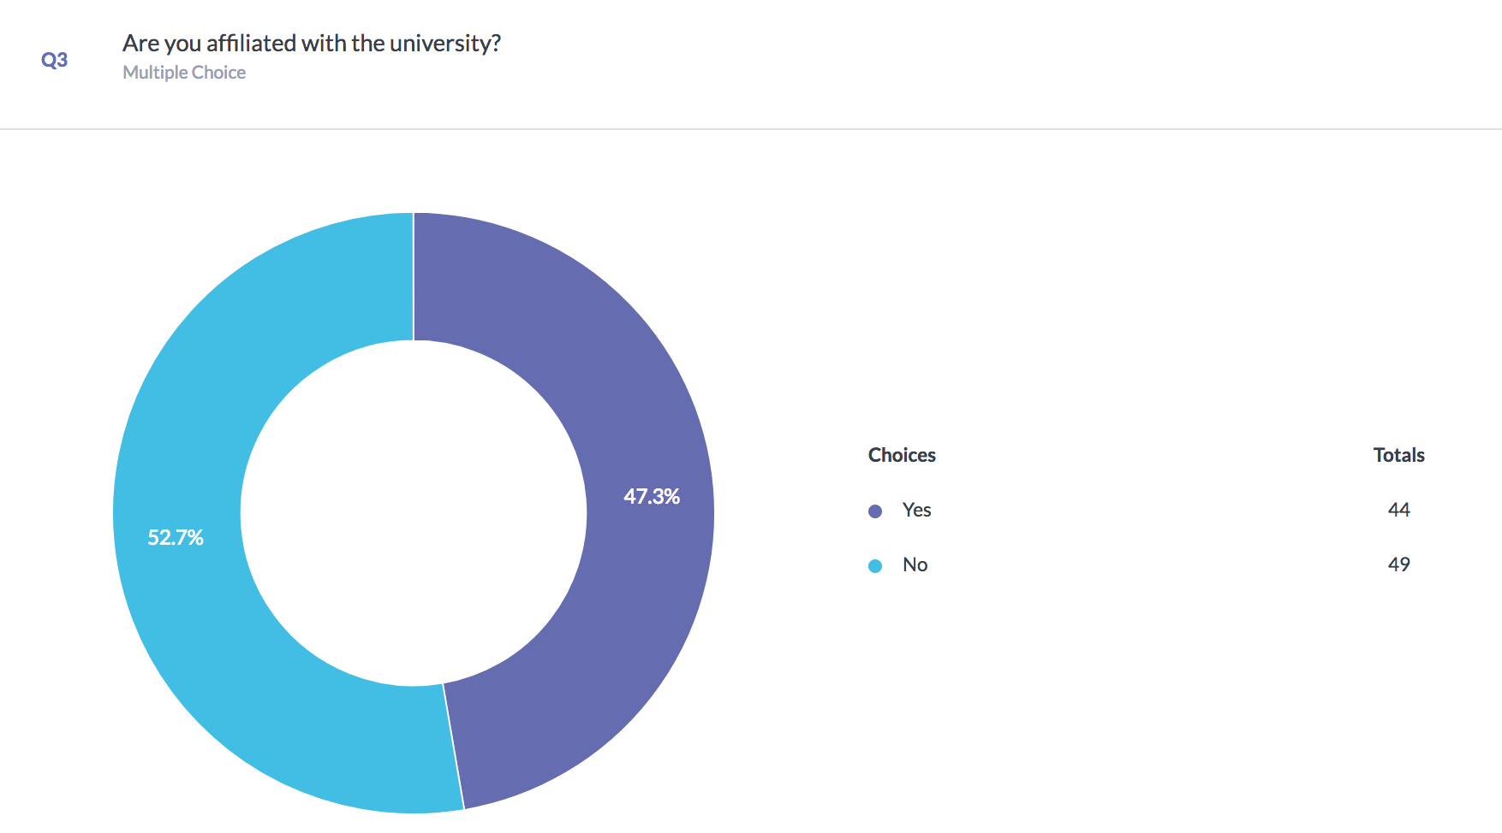

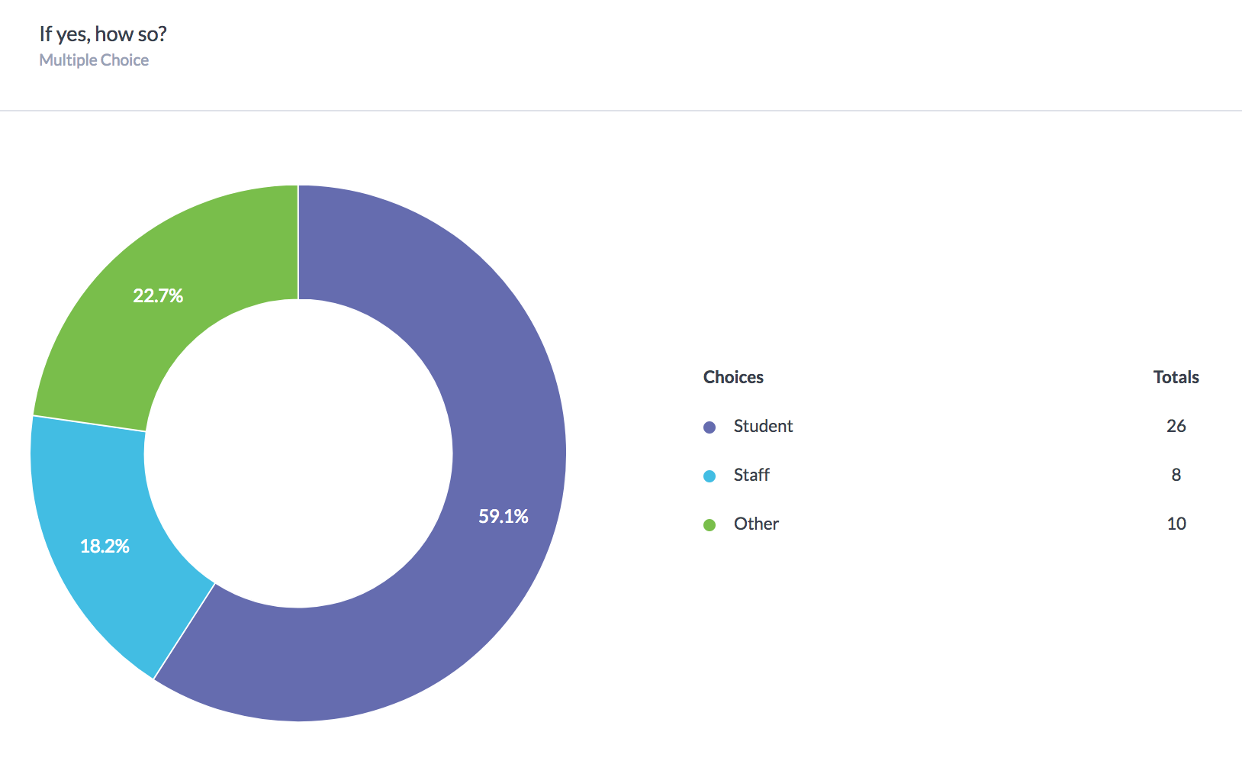

As shown above, just under half of all market consumers are affiliated with the university in some way (47.3%), with over half of those people being students (59.1%).

Annual Household Income
Speaking to the accessibility of the market, the following graphic portrays the average income of a Sackville Farmers’ Market Consumer. It should be noted that the option to indicate that the respondent is a student was not provided, which may have altered the results.
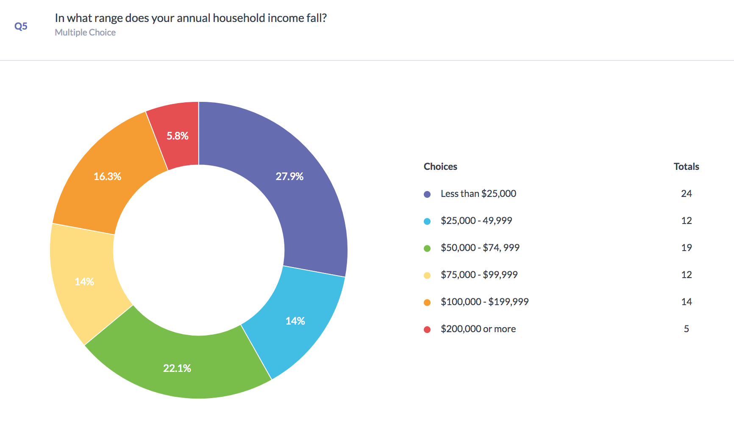

As seen above, there is once again a wide range of responses with no specific answer taking the majority. Many respondents annual household income falls under $25,000.

Market Tendencies & Habits
The following four questions provide an outline of how far consumers travel to the market, how often they attend the market, how much time they spend at the market once they arrive there and how much they usually spend on market products. The final question of this section indicated how long the consumer has been making use of the market’s presence of the town, in its previous locations.
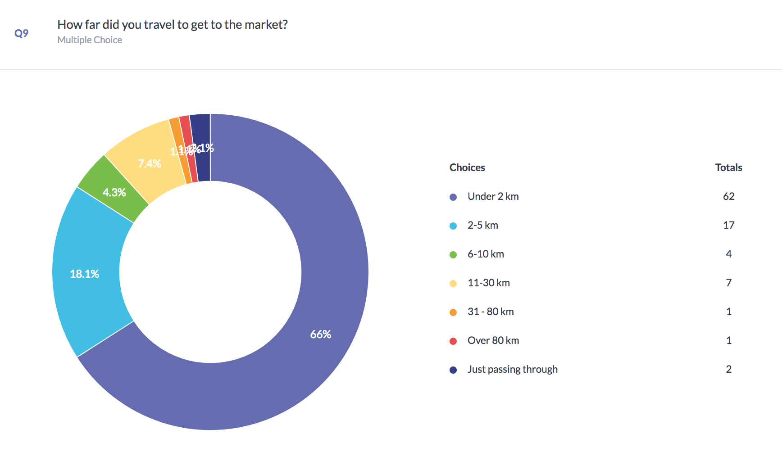

The majority of consumers (66%) travel less than 2km to attend the market, which speaks to both the size of the town and the type of consumer who visits regularly.
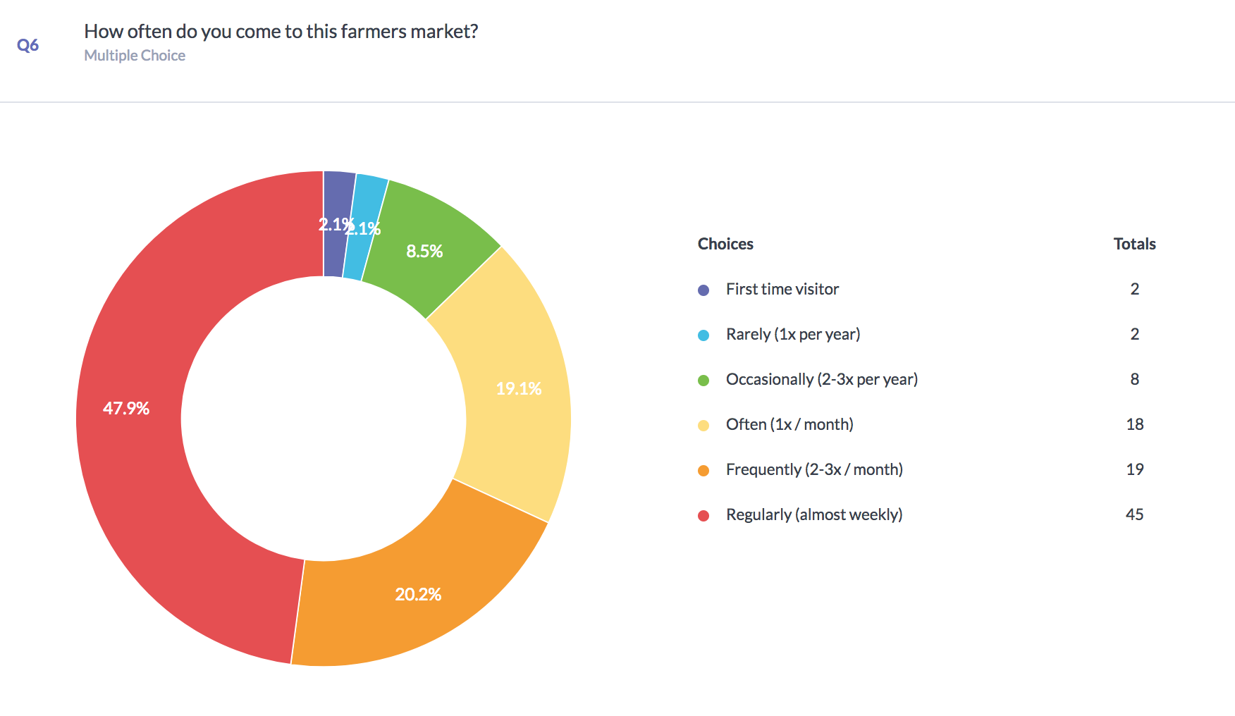

Almost half (47.9%) of consumers who answered the survey are regular, weekly customers of the Sackville Farmers’ Market. Because of the nature of this survey, it should be taken into account that it may have been more likely for regular consumers to answer the survey than for non-regular consumers to answer it, especially given that regular consumers would have seen the survey set up 5 Saturdays in a row.

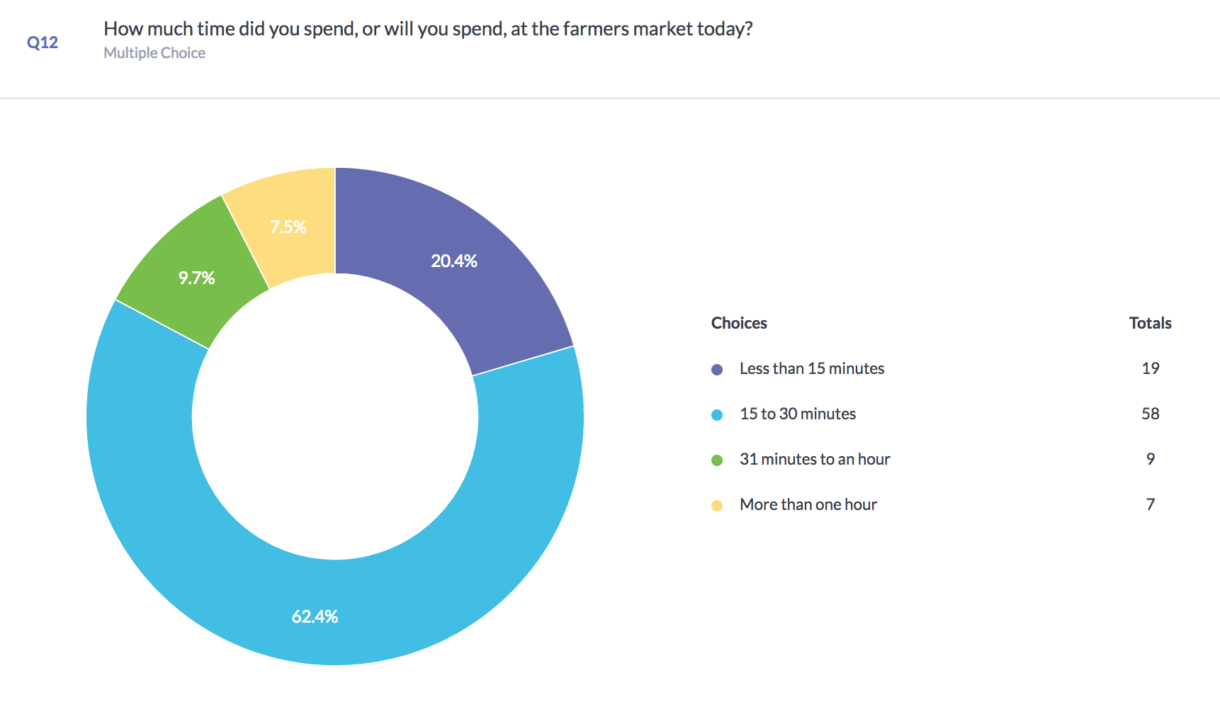

Most consumers (62.4%) spend 15 – 30 minutes at the market on each Saturday that they visit.

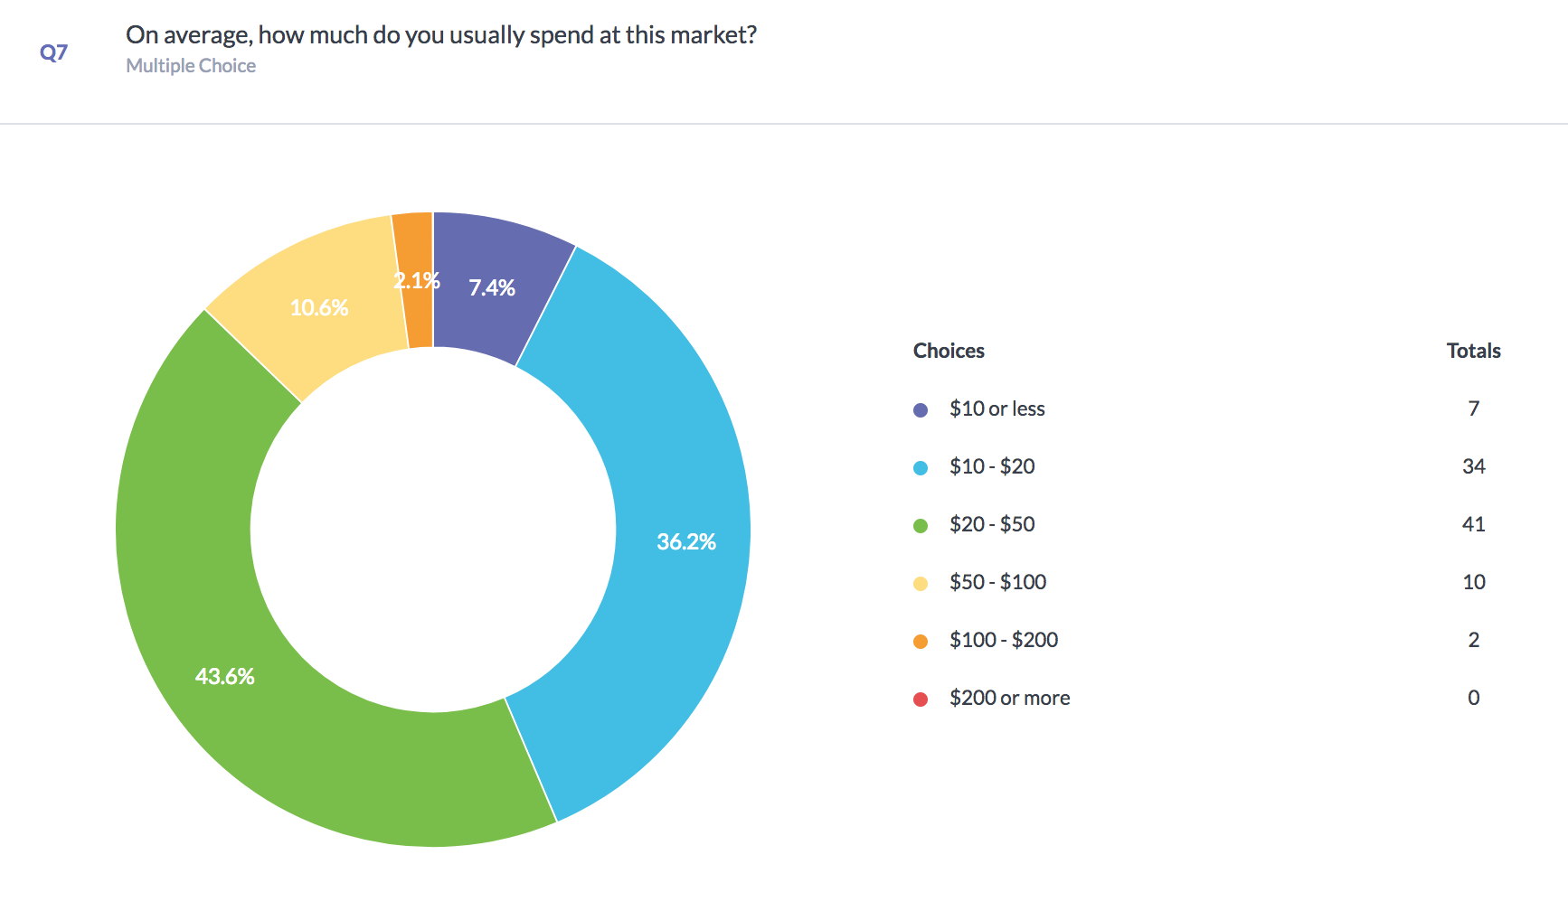
Many consumers (43.6%) spend $20 - $50 each week that they visit the Sackville Farmers’ Market, and only 7.4% spend less than $10.

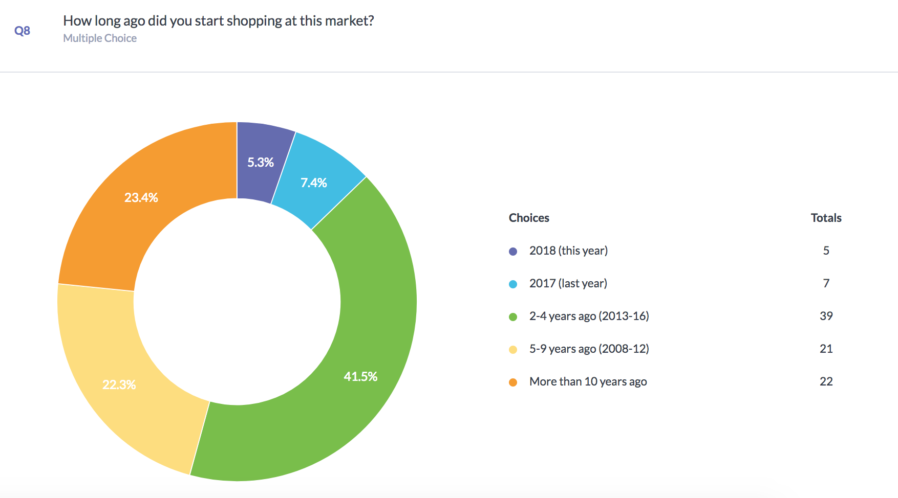

Many consumers (41.5%) have been shopping at the market for 2-4 years, but 45.7% have been shopping at the market for more than 5 years. Very few respondents (5.3%) are new to the market.

Town Impact
The following two questions are meant to provide a sense of what kind of impact the market has on the local economy on a Saturday morning.

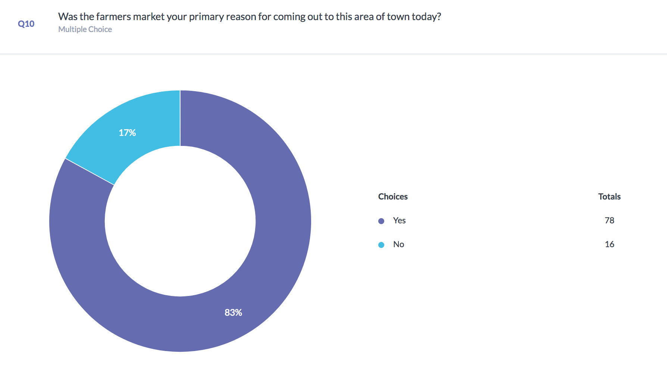
For 83% of respondents, the market was their primary reason for coming to downtown Sackville. This indicates that the market draws a large amount of people (78 at least) out of their homes on a Saturday morning.
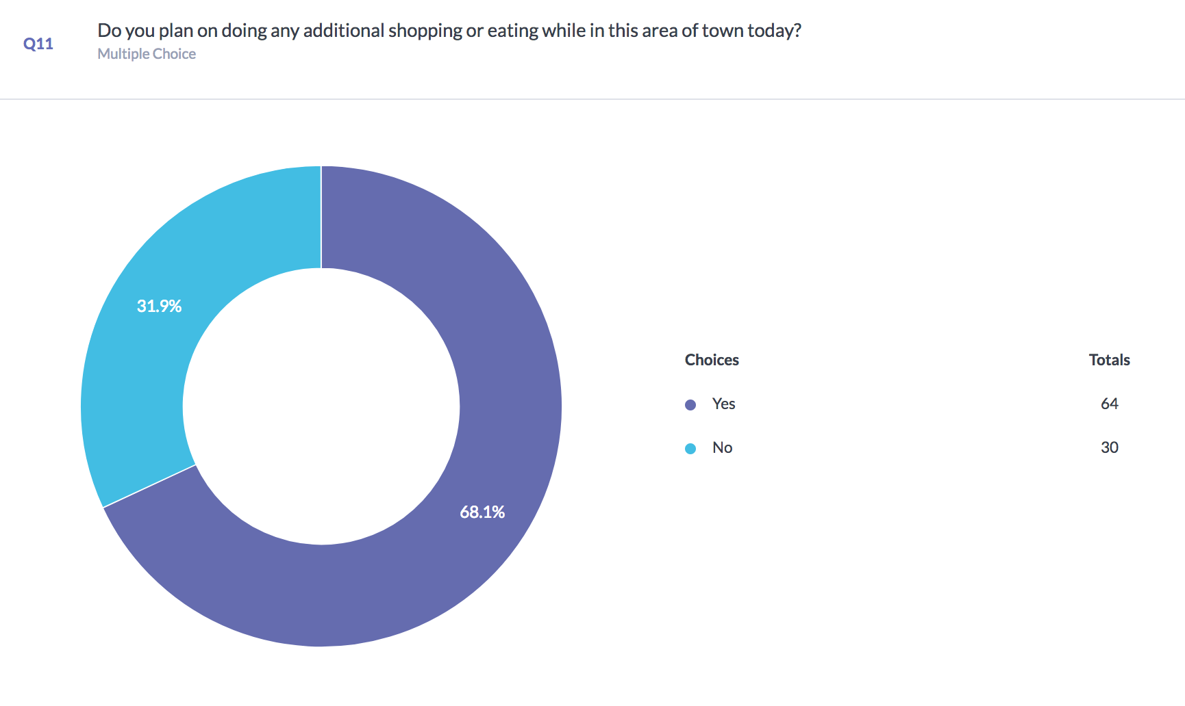

68.1% of respondents indicated that they intended to do additional shopping or eating in town before/after visiting the market. Combined, these are significant results, as they provide evidence that many people leave their homes primarily to come to the market, but they stay in town to access additional local businesses, proving that the market has a meaningful impact on Sackville’s economy.

Values: Market Interactions
The next set of questions were present as a scale, allowing consumers to rank the importance of various aspects of the Sackville Farmers’ Market.
Below shows the results of how important consumers find interacting with other community members and how important consumers find interacting with vendors.

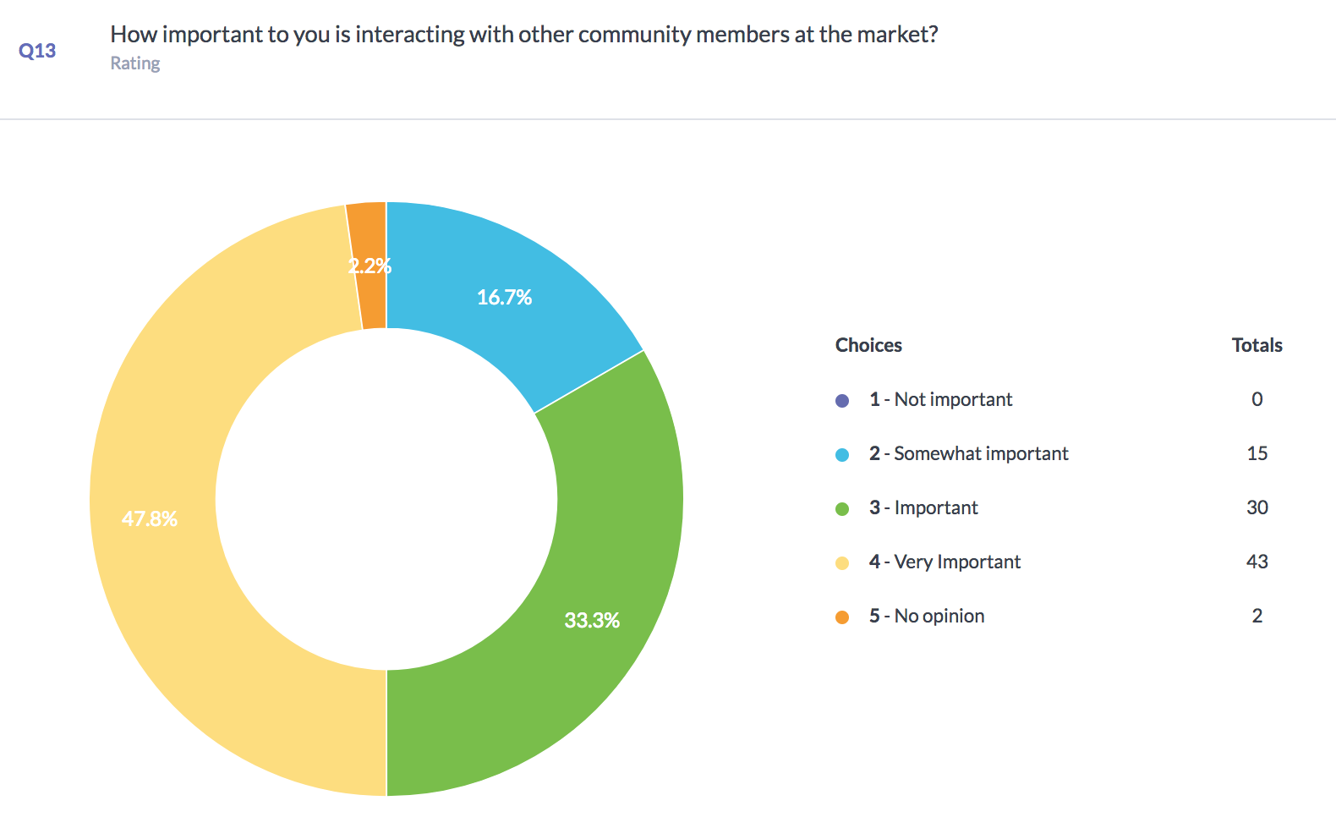

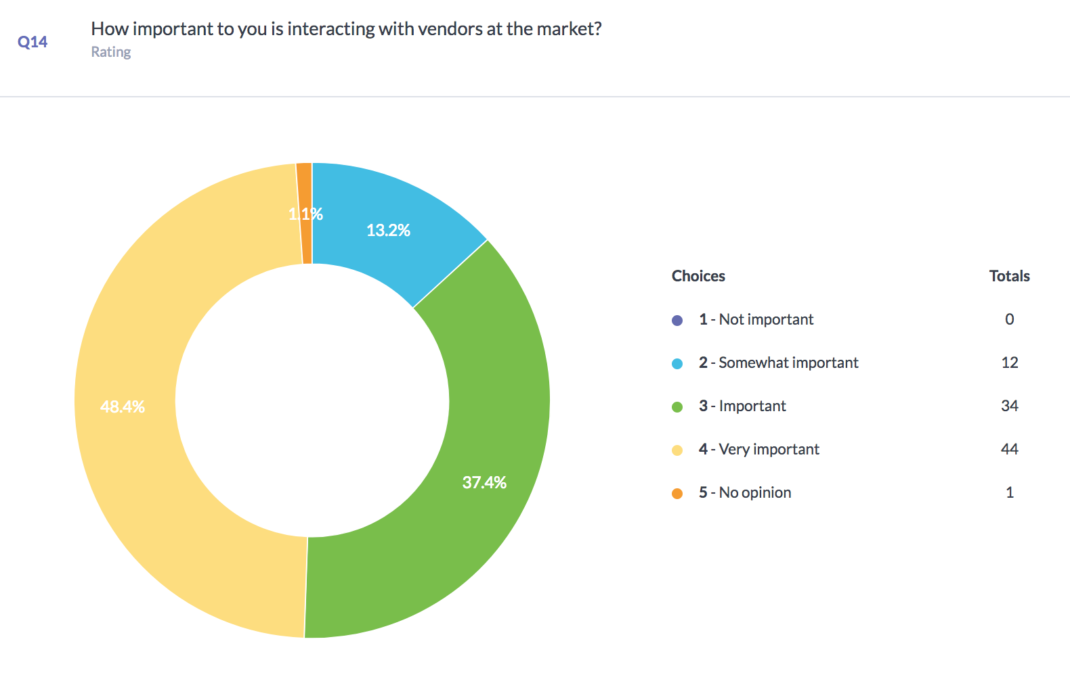
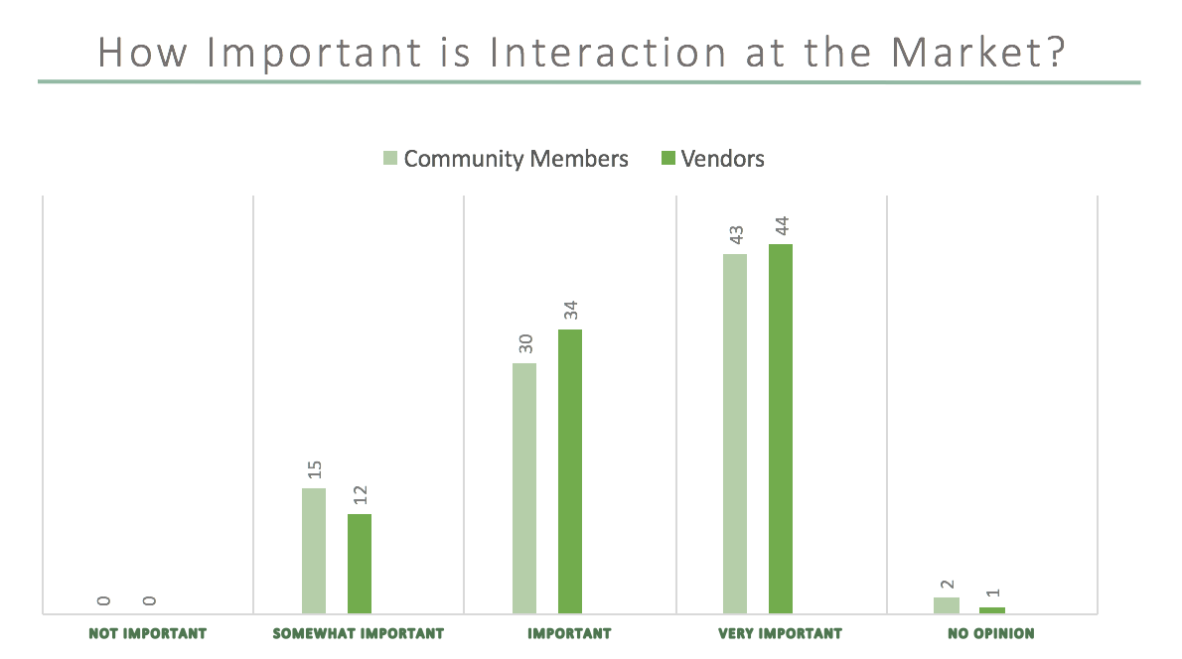

As shown above, most consumers find all types of market interactions to be important. Only 0.6% more consumers found interacting with vendors to be more ‘very important’ than interacting with other customers.
Values: Food Qualities
The next set of questions were also presented on a scale of importance, but had to do with what characteristics market consumers would like their food to have. These questions were asked to gain an understanding of what kinds of food consumers seek to acquire by doing their grocery shopping at the weekly market instead of or in addition to grocery stores, supermarkets or big box stores.

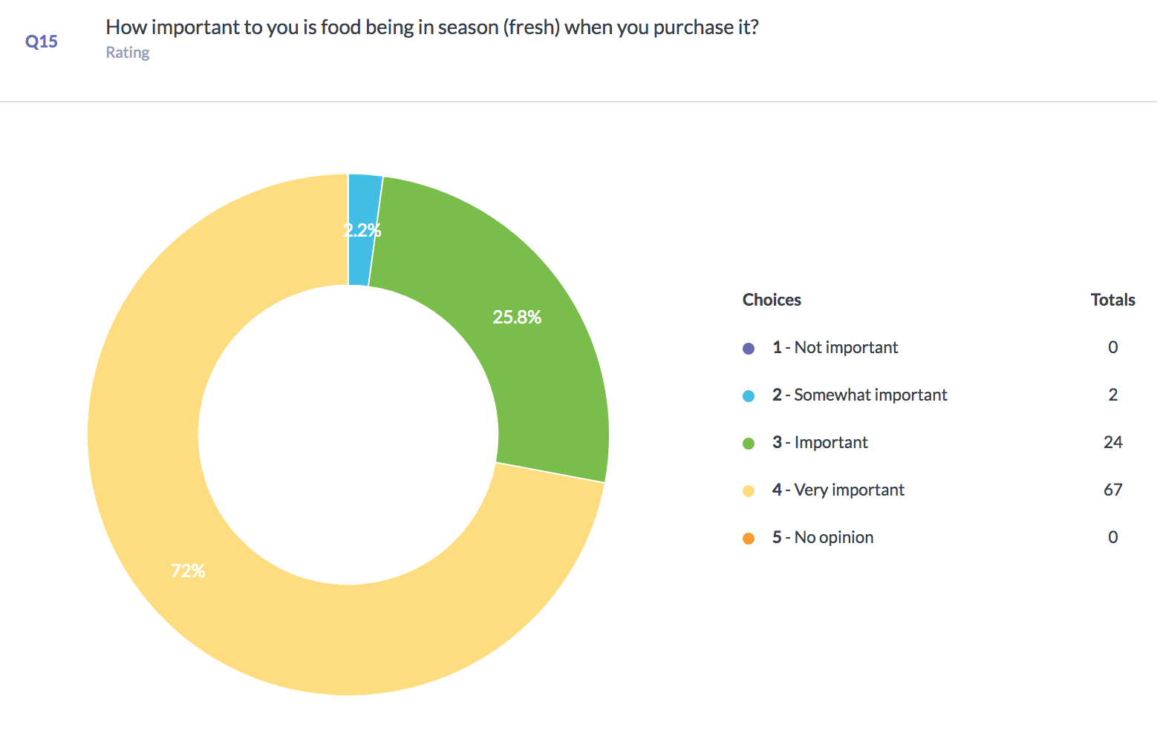
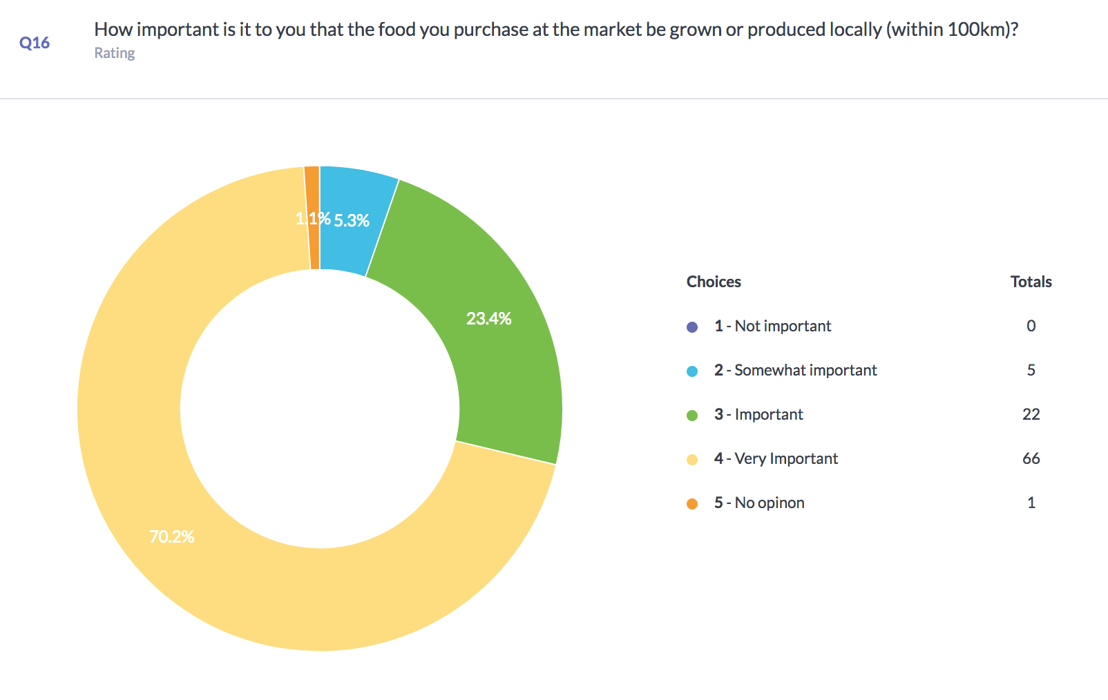
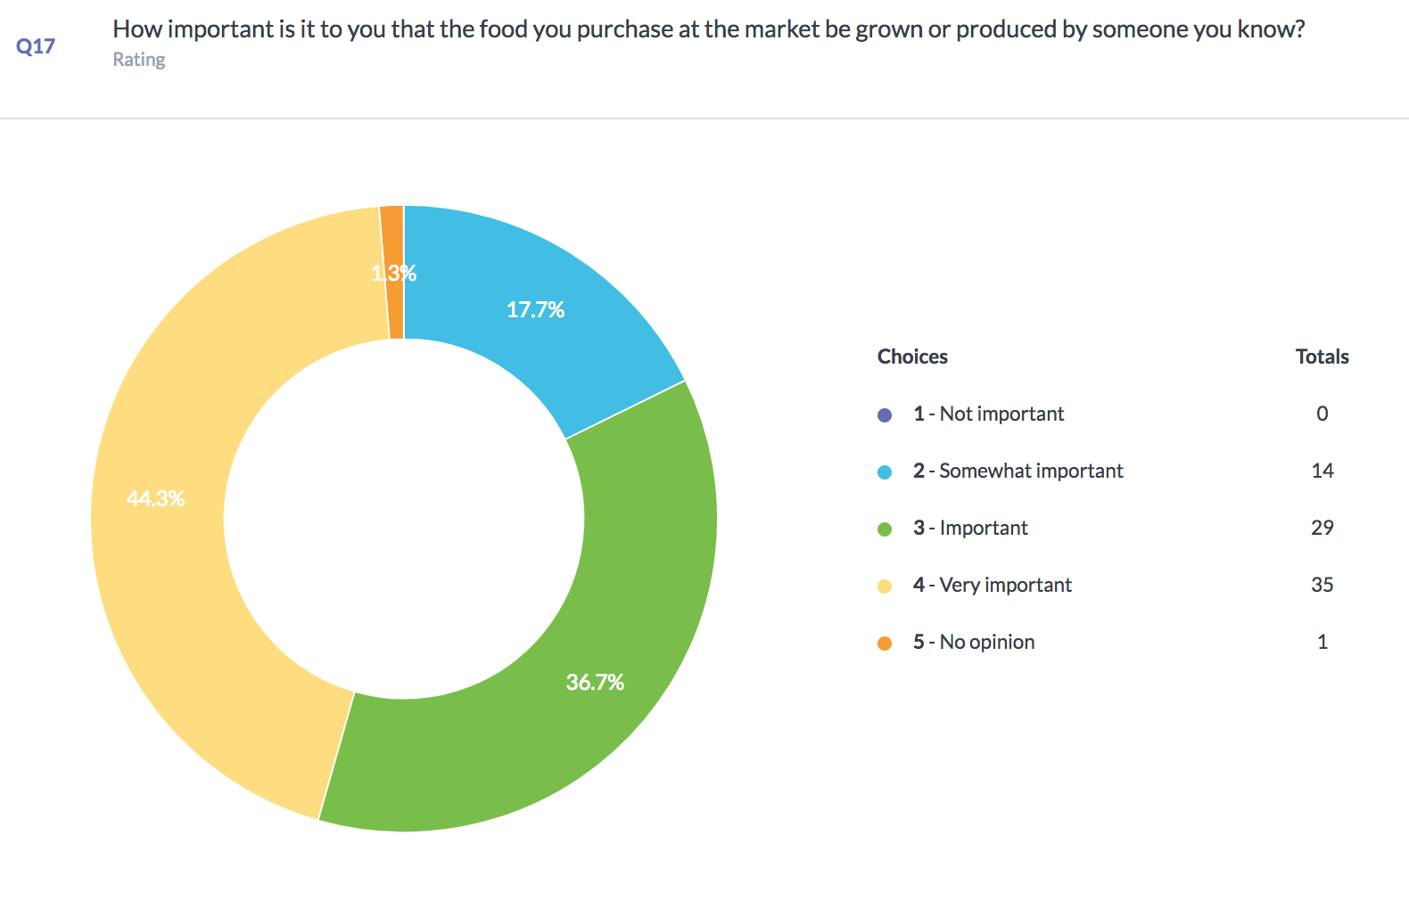
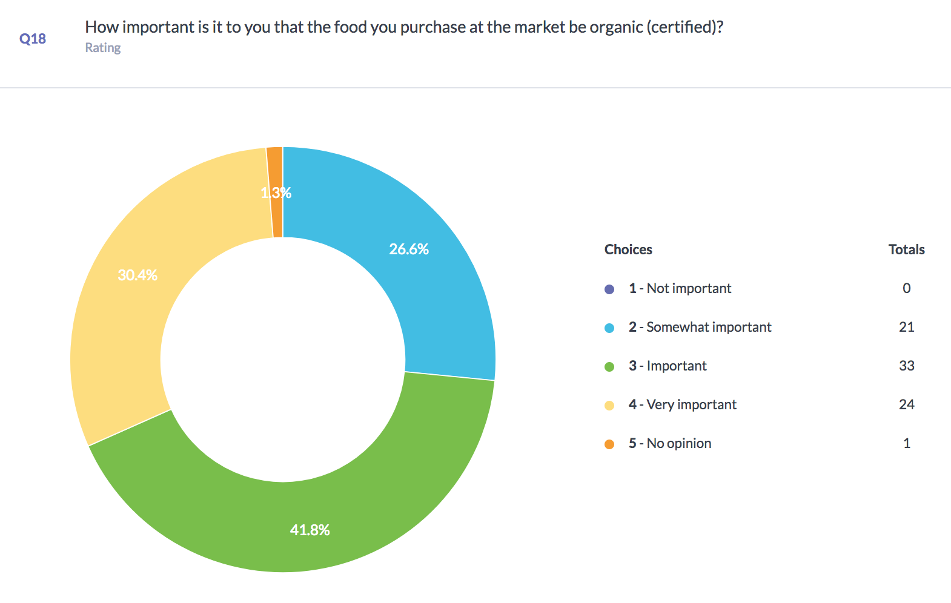
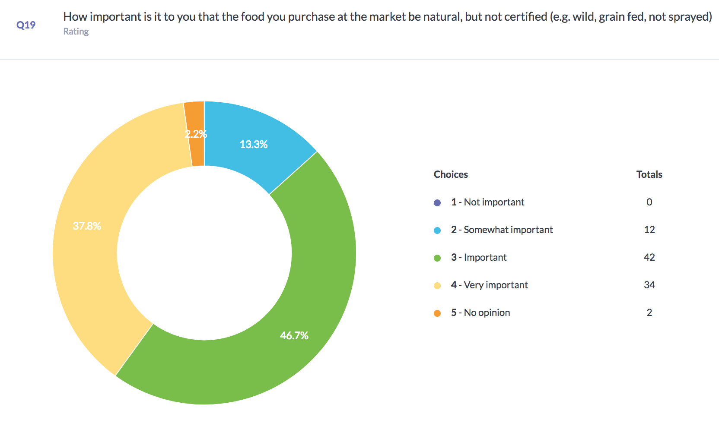

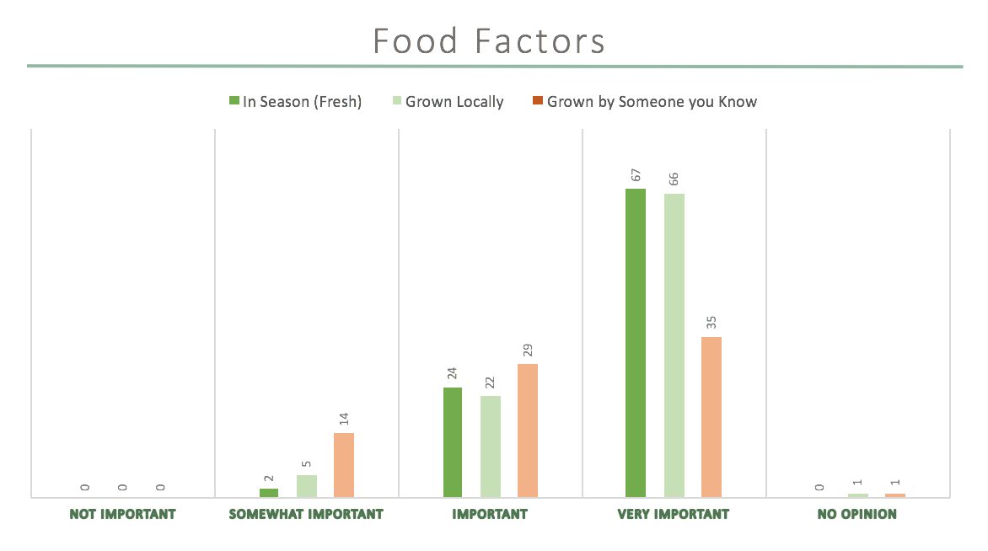
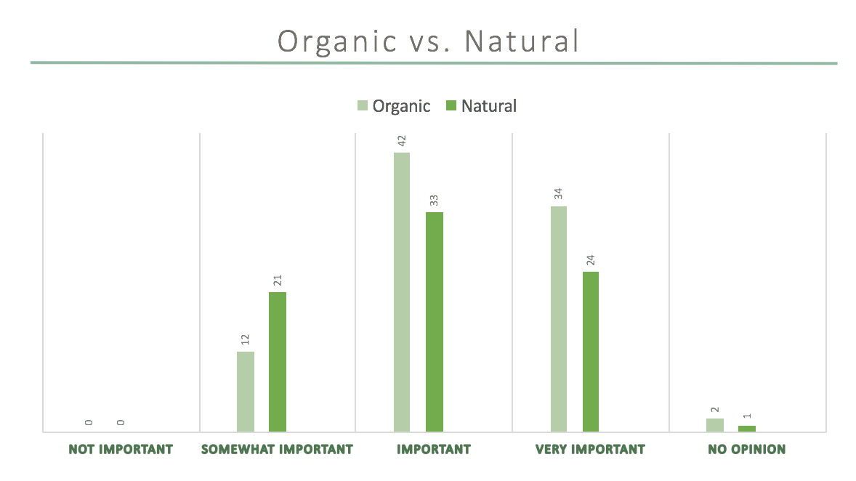

To summarize these results on food factors, the majority of consumers value fresh and locally produced food as being at least important, if not very important. Some consumers also found it at least somewhat important that the food be produced by someone they know, and many (44.3%) found this to be very important.
There appears to be an inclination for consumers to value food that is certified organic, but there are overall more consumers who want their food to be natural but not necessarily certified. Many respondents, while answering the question, indicated that they do not always realize the difference
What is missing from the Sackville Farmers’ Market?
The final question on the consumer survey was a written response question asking consumers what they felt was missing from the market. Of the 94 respondents, 41 wrote down something for this question. Below is a word tree showing some but not all of the answers provided for this question:

It should be noted that the most commonly named answers were coffee (9 times), seating areas (5), and a wider variety of prepared food (6).

Vendor Survey
In total the vendor survey received 12 respondents over the course of 2 weeks. Because it was indicated to respondents that each question was optional, not every question received 12 answers. Also, it should be noted that due to only receiving 12 responses these survey results may not be representative of the overall vendor profile at the Sackville Farmers’ Market.

Vendor Profiles
The first set of questions were laid out as multiple choice style, indicating vendors’ experience selling at market and what they sell.
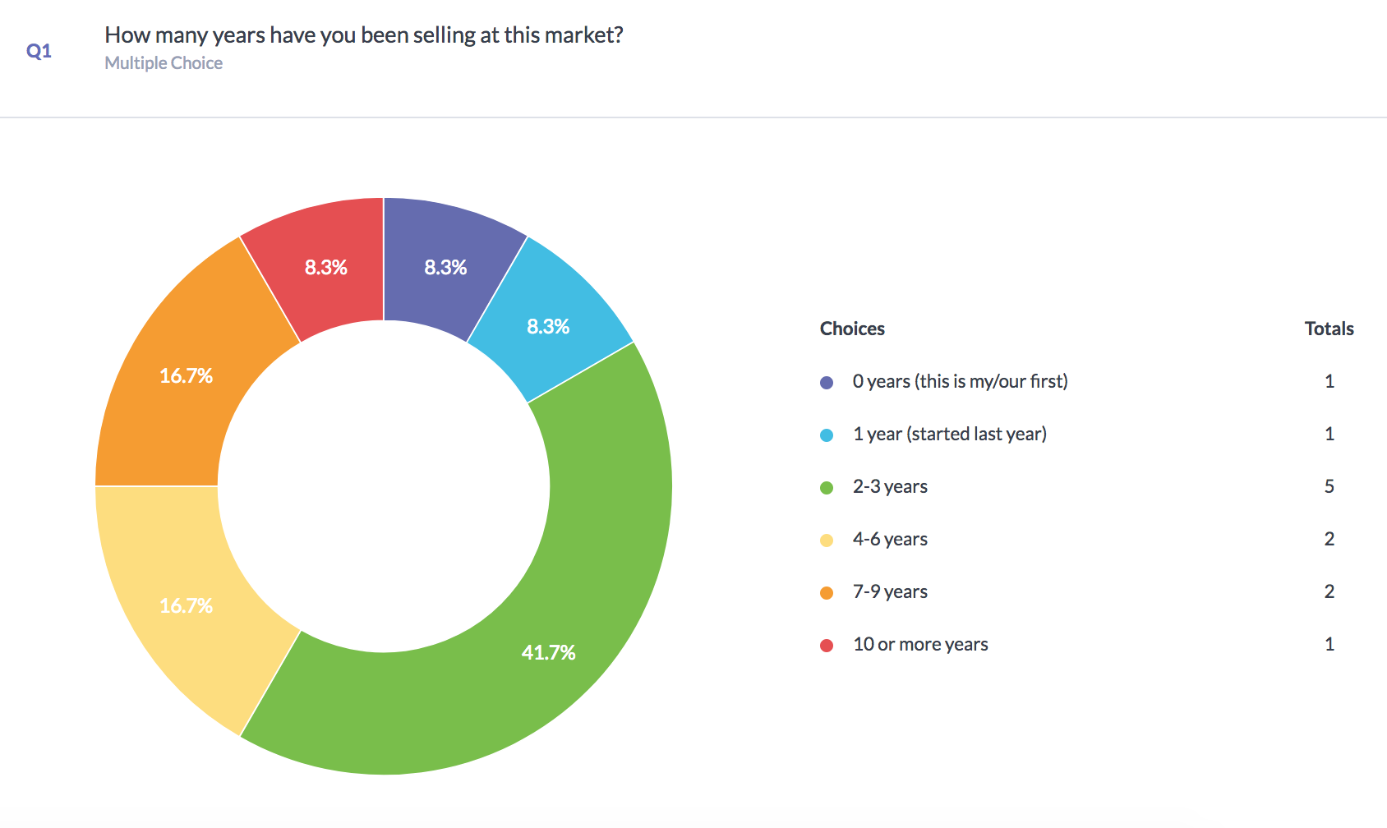
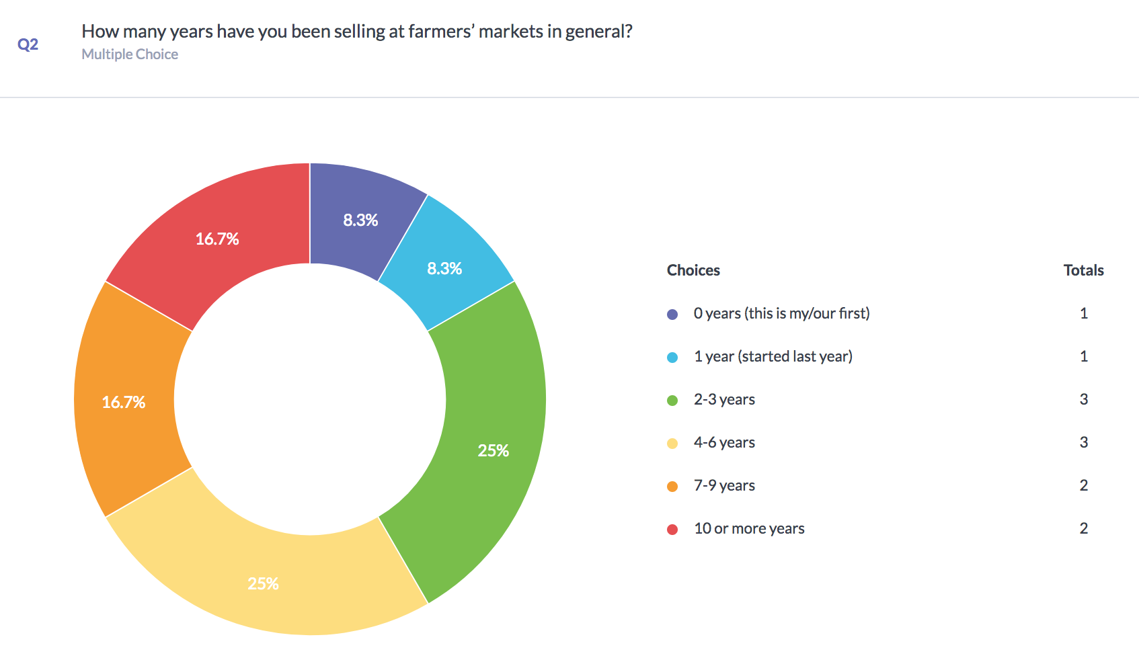
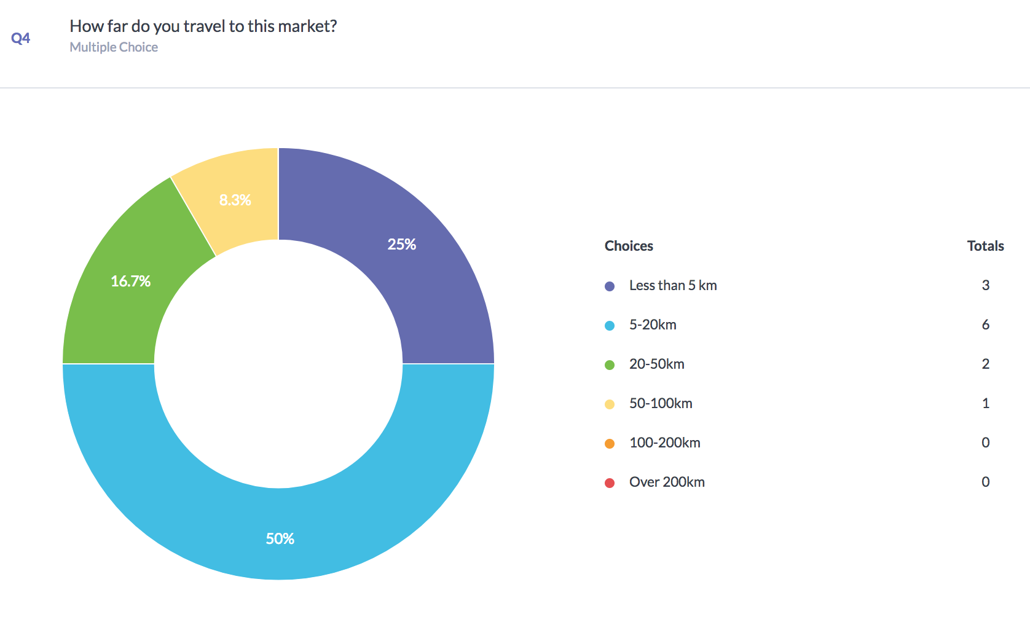

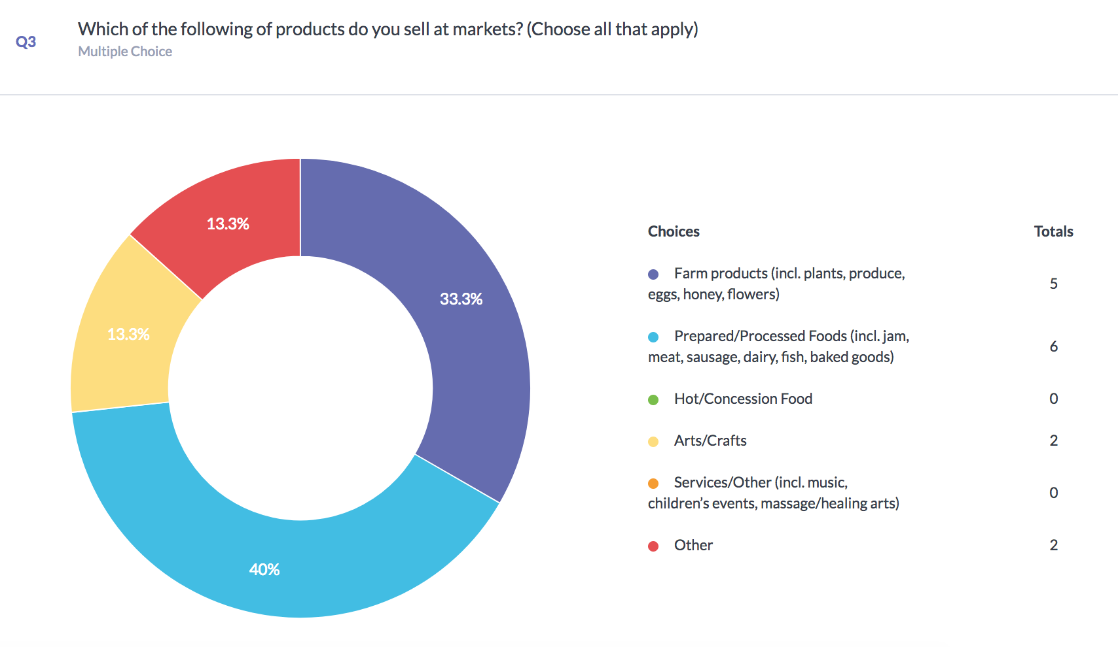

In addition to the results shown above, it should be noted that the majority of vendors’ time commitment to preparing their products for the market was between 0-10 hours (58.3%), and that 5 vendors spent spend 10-30 hours preparing their products.

Value Added for Vendors
The following question was intended to provide an idea of what kind of things vendors gain from selling their products at the Sackville Farmers’ Market.

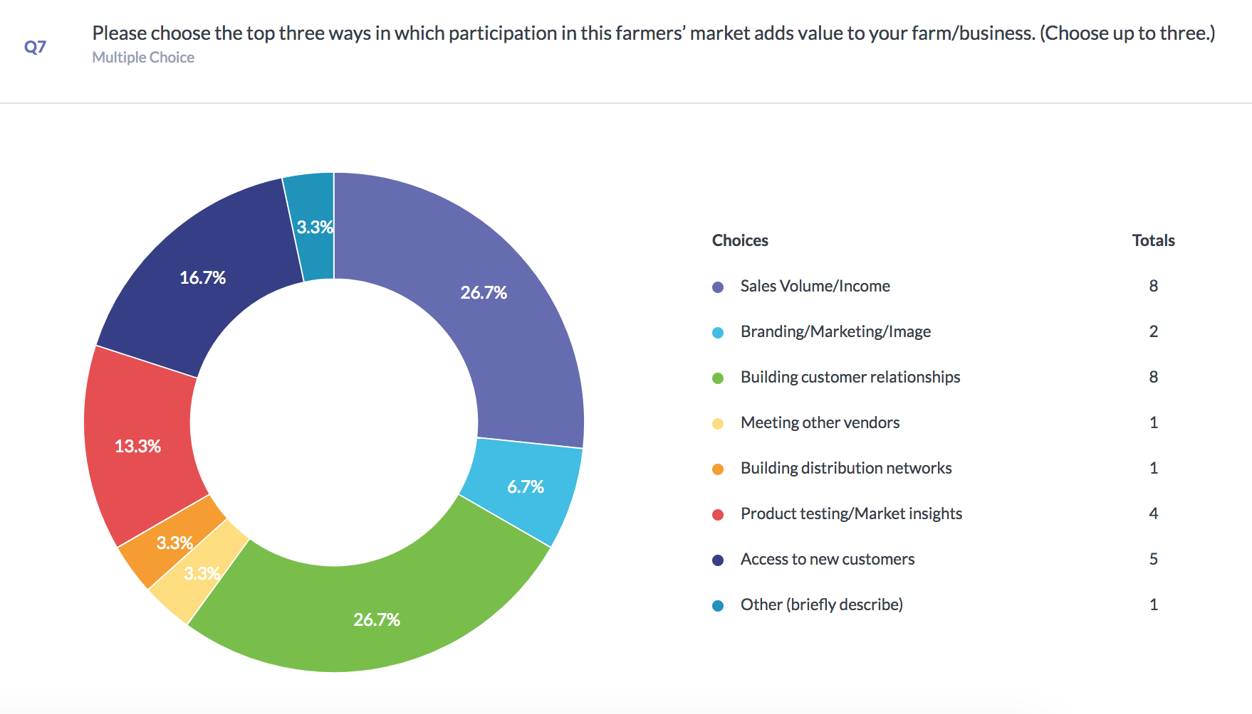

The answers to this question varied significantly, but most vendors agreed that an increase in sales volume and income and building relationships in customers were the biggest ways that the market added value to their business.

Market Income
The following question was provided to provide insight as to how much of a vendors income comes from the sales of their product at the Sackville Farmers’ Market.

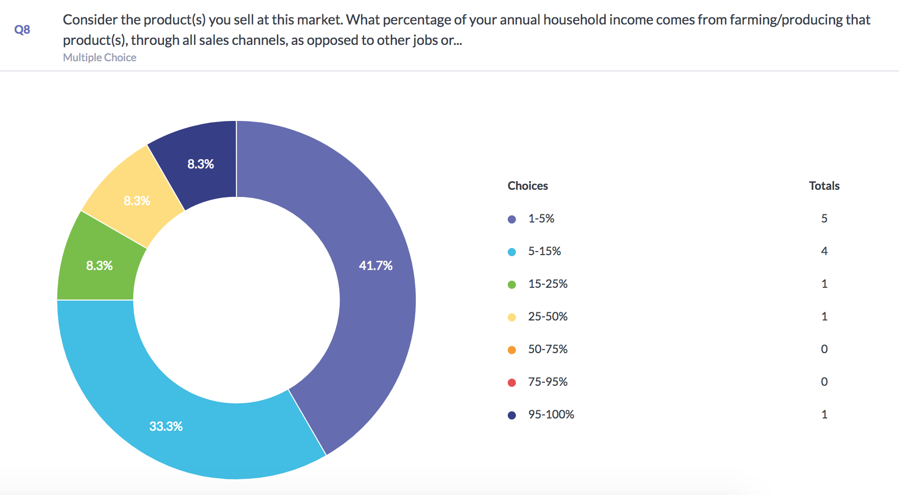

For most market vendors, the products they sell provide very little of their household income as opposed to their other jobs or channels of income.

Below are some of the answers provided to the open-ended question: What value does contact with other vendors at this market provide?

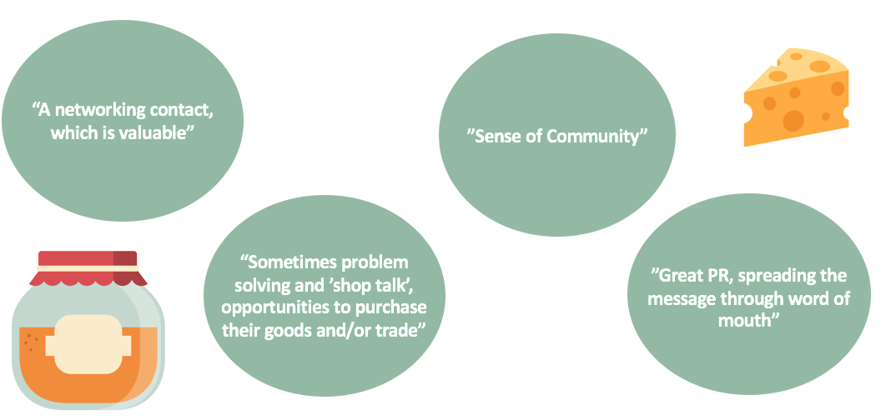

The next page features a few of the anonymous answers to the question posed to vendors: Please describe - in your own opinion - if this market fosters a sense of community. Telling a story is welcome.
“Markets are a great reminder to everyone that a sense of community is fostered by such events. All family members benefit from the importance of community unity and fosters confidences and good social skills.”

“The market is like my home, my church, even. I've been working at this market in various capacities for five years and have come to depend on the weekly flow of people to fill up my social/emotional reserves. […] The farmers market is the best thing about Sackville…”

“The market should be supported by the town administrated as well as promoted by elected officials. When was the last time the mayor and/or councilors attended the market on a Saturday or had a municipally supported event held in conjunction with the market on a regular basis?”

Recommendations: What could be next?

Case Studies and Suggestions

CalFresh

An interesting example of how markets in America have assisted with diminishing food security comes out of California, where they’ve established a ‘market match’ program. Essentially, the California Nutrition Incentives Act created financial incentives for CalFresh to match dollars spent on produce at farmers’ markets. Every CalFresh dollar spent on produce earns a matching dollar to also spend on produce. So it ends up empowering low income shoppers to make healthy food choices while also supporting local farming. It also increased market purchases by 300% at participating markets, which is a lot.

Space

The Sackville Farmers’ Market currently operates out of the Sackville Commons, a collaborative space that allows for community participation and enjoyment. It is important that the market be set up in an accessible space that takes into account foot traffic in the area. However, it can be argued that this space may only provide temporary benefits for the market. While it is an improvement upon the winter market being separated in Bridge Street Café and Ducky’s Bar, it still does not allow for spacious community interactions and easy flow.
Many farmer’s markets set themselves up in ‘aisles’, allowing for shoppers to walk laps of the market to contemplate purchases. Consumer habit patterns have shown that keeping customers in a store for longer to purchase now requires them to have personal space and not to feel rushed.
Additionally, one of the most common comments received from consumers completing the survey was that the market lacks seating, presumably to enjoy their food, socialize and contemplate further purchases.
Wolfville Farmers’ Market: Case Study

The Wolfville Farmer’s Market began operations in 1992, and operates on Saturdays year-round and Wednesday evenings from May until Christmas. It is located 650m away from the Acadia University campus in a university-owned building that the market leases for $1 per year.
The management of the Wolfville Farmer’s Market notes that the Wolfville Farmer’s Market and its vendors find that the market serves as a hub from student and community interaction, and that there is a very strong relationship between Acadia and the market. Student involvement in the market happens on a regular basis. As mentioned, the very building that the market takes place in is university-owned, and the market has invested a considerable sum in renovations for the building, increasing its value. The Market is often used by university groups, particularly student associations, for their banquets to avoid the high cost of catering on campus.
The Wolfville Farmers’ Market also offers many avenues to volunteer with the market, some of which are affiliated with specific programs of study at Acadia and some that are not. Individuals can easily volunteer at the market as Info Booth Greeters, Decorators, assisting with projects, as a social media experts, etc.
The Market also benefits from student research capabilities, particularly for marketing purposes with business students. Additionally, students are involved in project work that takes place at the market. The Community Development students regularly supervise the waste separation station and have organized special events for the market. Nutrition students organize suppers every Wednesday in season (about 9 months of the year) by providing a plate, salad, silverware and water, then customers tour the booths to buy their prepared food. There is reasonable recognition in the community that students provide these services.

Potential for Collaboration with Mount Allison University

This project was completed by a Mount Allison University student in collaboration with the Sackville Farmers’ Market. Universities across Canada are beginning to introduce their students to the benefits of community collaboration and partnerships.
University towns are unique, especially when students make up a significant amount of the town’s population when classes are running. These towns typically face different challenges and dynamics than other small towns, and Sackville, New Brunswick can undoubtedly attest to that. Of the 5331 people living in Sackville, 2557 of them are Mount Allison Students (…), making Sackville 32% students. This does not account for the additional members of the Sackville community who are Mount Allison faculty, staff and alumni.
Of the 29 Farmers’ Markets in New Brunswick, Sackville is especially unique in this way. Currently, there are very few channels involving students being used to in marketing the market.
A common conversation had amongst students is how ‘burnt out’ Sackville citizens must feel due to the large amount of fundraising efforts that student groups undertake within the community, not to mention the surveys and studies that are frequently undertaken by students studying within certain programs. The market could serve as a potential new avenue for students to reach the larger Sackville community.
Through the Mount Allison Student’s Union (MASU), there is also a Community Services Coordinator whose role is to facilitate forms of volunteer collaboration between the community and students. This is another potential avenue that the market could explore utilizing.

Below are specific suggestions that may be feasible for the Sackville Farmers’ Market:
- Have 1 or 2 student representative volunteers who advertise the market specifically to students through on-campus and social media channels.
- Collaborate with various academic departments on campus (i.e. Geography and Environment, Commerce, or Music) to recruit weekly volunteers to complete various tasks that market management considers useful (i.e. waste sorting, marketing, greeters, entertainment).
- Target potentially food insecure students and community members by offering ‘discounts’ or weekly food subscription programs.
- Find an indoor space that allows for seating, more vendors, and better flow.
- Engage the community through collaboration with the Town of Sackville.

Conclusions

Based on the results of both surveys and research, the Sackville Farmers’ Market is clearly a location and experience that is valued very highly by both the vendors and consumers who attend it. That being said, there is still room for improvement in many areas that could increase the marketing value and collaboration potential with other members of the community.

Work Cited

Baber, Laura M., and Edward A. Frongillo. "Family and Seller Interactions in Farmers' Markets in Upstate New York." American Journal of Alternative Agriculture 18.2 (2003): 87. ProQuest. Web. 5 Feb. 2018.

British Columbia Association of Farmers’ Markets, and Vancity Community Foundation. “Farmers’ Market Impact Toolkit User’s Guide.” July 2013.

Bullock, Simon, and Friends of the Earth. “The Economic Impact of Farmers' Markets.” Sept. 2000.

Campbell, Lindsay, and Anne Wiesen. “Restorative Commons: Creating Health and Well-Being through Urban Landscapes.” Northern Research Station, Jan. 2011.

Crawford, Kyler, and Keltie Butler. “Nova Scotia Farmers' Market Economic Impact Study 2013: Cultivating Community Economy.” 2014.

Dowd-Uribe, Brian, et al. “Can Farmers’ Markets Simultaneously Address Food and Farm Security? A Case Study of San José, Costa Rica.” 2015.

Malagon-Zaluda, Eduardo. Measuring the Economic Impact of Farmers’ Markets on Local Economies in the Basque Country. 3 Jan. 2018.

Millichamp, Anna, and Danielle Gallegos. "Comparing the Availability, Price, Variety and Quality of Fruits and Vegetables Across Retail Outlets and by Area-Level Socio-Economic Position." Public health nutrition 16.1 (2013): 171-8. ProQuest. Web. 5 Feb. 2018.

New Brunswick Food Security Action Network. “Farmers’ Market Best Practices Toolkit: A Guide for Community Organizations in New Brunswick.” 2015.

Oberholtzer, Lydia, Carolyn Dimitri, and Gus Schumacher. "Linking Farmers, Healthy Foods, and Underserved Consumers: Exploring the Impact of Nutrition Incentive Programs on Farmers and Farmers' Markets." Journal of Agriculture, Food Systems, and Community Development 2.4 (2012): 1-15. ProQuest. Web. 5 Feb. 2018.

Rossi, James D., Thomas G. Johnson, and Mary Hendrickson. "The Economic Impacts of Local and Conventional Food Sales." Journal of Agricultural and Applied Economics 49.4 (2017): 555-70. ProQuest. Web. 5 Feb. 2018.

